Madagascar

## Respect for rule of law (ROL) data

The data set shows the data on the respect of the rule of law for the country.

## # A tibble: 19 x 5  
## country iso3c date ruleOfLaw ruleOfLawCategory4   
## <chr> <chr> <dbl> <dbl> <chr>   
## 1 Madagascar MDG 1996 -0.404 ROL moderately disrespected  
## 2 Madagascar MDG 1998 -0.519 ROL moderately disrespected  
## 3 Madagascar MDG 2000 -0.244 ROL moderately disrespected  
## 4 Madagascar MDG 2002 -0.300 ROL moderately disrespected  
## 5 Madagascar MDG 2003 -0.235 ROL moderately disrespected  
## 6 Madagascar MDG 2004 -0.246 ROL moderately disrespected  
## 7 Madagascar MDG 2005 -0.353 ROL moderately disrespected  
## 8 Madagascar MDG 2006 -0.446 ROL moderately disrespected  
## 9 Madagascar MDG 2007 -0.384 ROL moderately disrespected  
## 10 Madagascar MDG 2008 -0.450 ROL moderately disrespected  
## 11 Madagascar MDG 2009 -0.734 ROL moderately disrespected  
## 12 Madagascar MDG 2010 -0.875 ROL moderately disrespected  
## 13 Madagascar MDG 2011 -0.888 ROL moderately disrespected  
## 14 Madagascar MDG 2012 -0.906 ROL moderately disrespected  
## 15 Madagascar MDG 2013 -0.913 ROL moderately disrespected  
## 16 Madagascar MDG 2014 -0.740 ROL moderately disrespected  
## 17 Madagascar MDG 2015 -0.687 ROL moderately disrespected  
## 18 Madagascar MDG 2016 -0.814 ROL moderately disrespected  
## 19 Madagascar MDG 2017 -0.858 ROL moderately disrespected

## Respect for rule of law (ROL) trend

The plot shows the trend of the respect for the rule of law for the country.

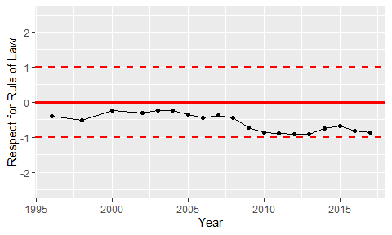

Trend of the Respect for the Rule of Law